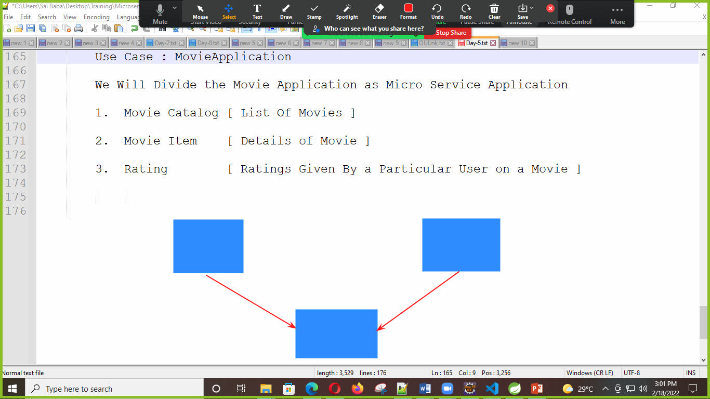

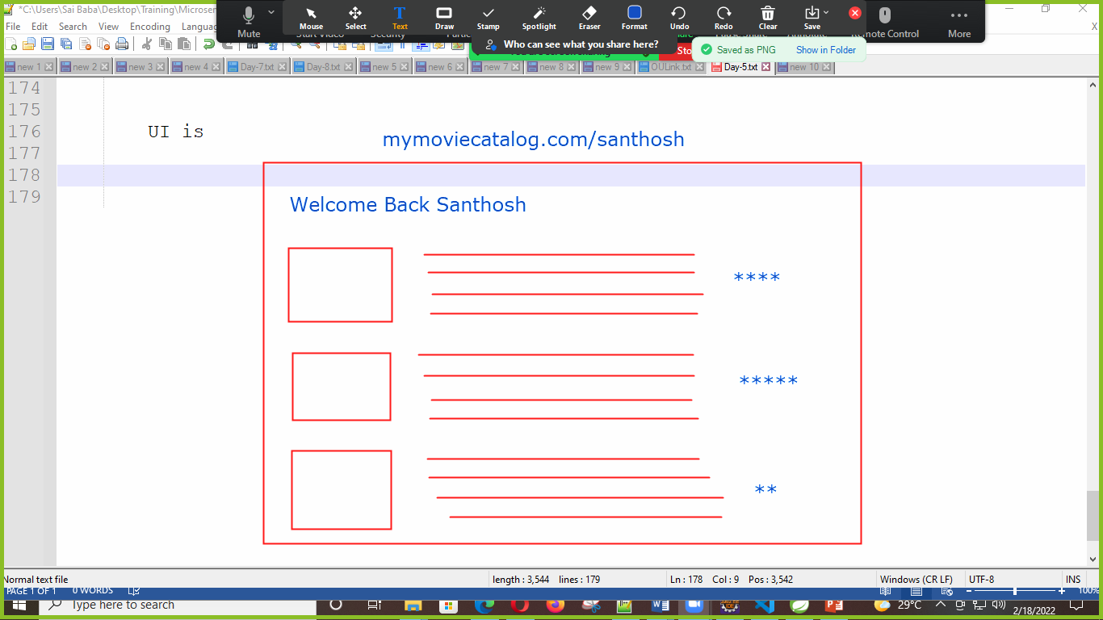

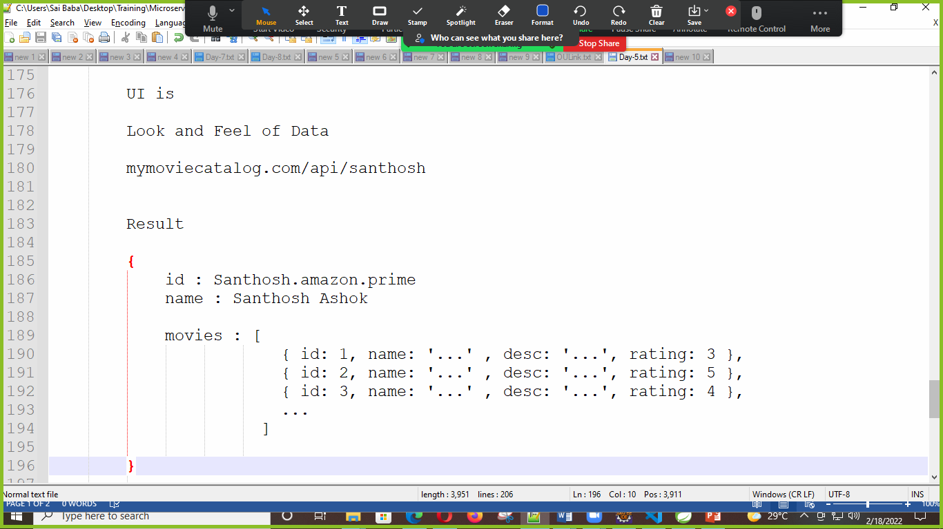

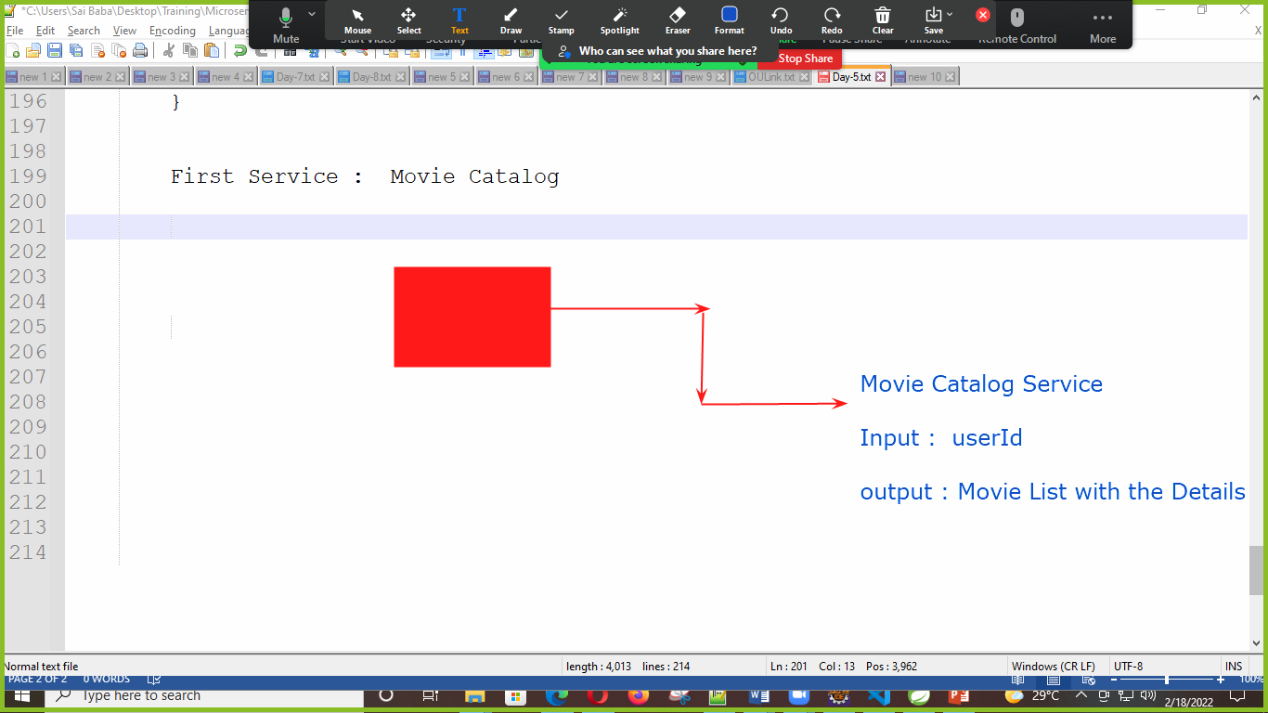

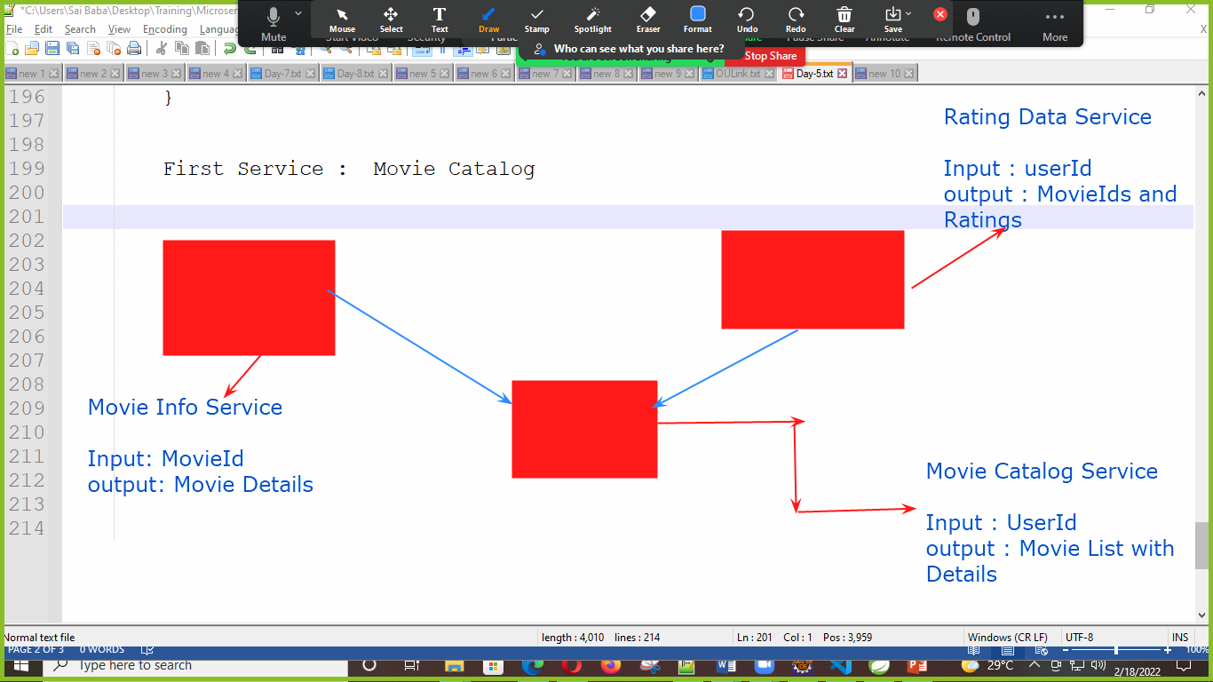

Movie Catalog Service

Input : UserId

Output : Movie List With [ Movie Details and Ratings Given By the Particular User

We Have To Create 3 Spring Boot Projects

1. Build User Movie Catalog Service API
2. Build Movie Info Service API
3. Build Rating Service API

**User Movie Catalog** Service API --- Will Call / Use the Other Services API [ **Info** and **Rating** ]